**Sales Analytics Report**

**AtliQ Technologies**

**Objective**: To understand customer and market performance for the FY 2019-2021 and provide recommendations

**Domain**: Sales | Marketing

**Tools used**: Excel, Power Query, Pivot tables

1. **Introduction:**

This Sales Analytics Report aims to provide an insight on the overall customer-wise and Market-wise sales performance for AtliQ company during FY 2019-23. The report highlights key insights and recommendations to improve sales effectiveness and identify growth opportunities.

**Customer performance Report**

* Net Sales for individual customer performance for FY 2019-21
* Customer performance comparison between 2020 vs 2021

**Market Performance Report**

* Net Sales for individual market for FY 2019-21.
* Market performance comparison of actual vs target sales revenue for FY 2021.

1. **Dataset Overview:**

The data for this analysis was sourced from AtliQ's sales database, covering the period from Sept 1, 2018 to Aug 1, 2021 of almost 800,000 Data points.

The Dataset contain data in 5 csv files:

* **dim_customer** table contains customer data like customer code (PK), customer name, platform, customer channels and the market
* **dim_market** table contains market data like market (PK), subzone and region
* **dim_product** table contains product details like product code (PK), product name, division, segment, category and variant
* **fact_sales_montly** contains net sales details with date, product code, customer code, quantity sold and net sales amount
* **ns_target_2021** table contains the net sales target for FY 2021 along with the market and date.

1. **Data Analysis**

**Step 1-** Extract, Transform and Load (ETL)

* Extract the csv files to Excel sheet
* Transform data
  + Promoting headers
  + Assigning appropriate data types
  + Checking unique values and treating duplicate values
  + Checking and treating null values and errors
  + Trimming spaces
* Loading the data to the data model

**Step 2-** Understanding the data

* Seeking relationship between data tables
* Identifying primary keys in the dimension tables and foreign keys in the fact tables
* Identify relevant data required to prepare performance report
* Identify any new column requirements

**Step 3-** Data Modelling

* Establishing relationships between different data sets using star schema

**Step 4-** Creating dim_date table using Power Query

**Step 5-** Creating user empathetic customer performance report.

1. **Results and Conclusions**

**Note:** Refer to the excel file/ PDF reports for more interactive information

* 1. **Customer Performance Report:**

Total Sales Revenue: During FY 2021, AtliQ generated a total of $598.9 M, in sales revenue, reflecting a 205% growth compared to the previous FY.

**Top 10 Customers with highest %age sales revenue growth in 2021.** Nova showed a whopping 2565 % growth. Contribution in the total sales revenue by these 10 customers is only 6.5 % in 2021.

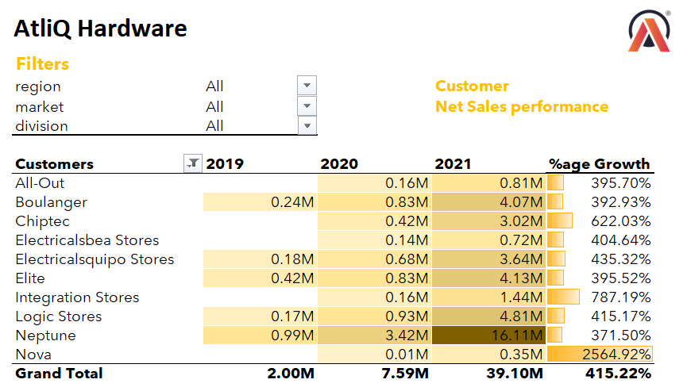

**Bottom 10 Customers with lowest %age growth in 2021** with Amazon being at the lowest at 118.87%. The sales revenue contribution by these 10 customers is 33 %.

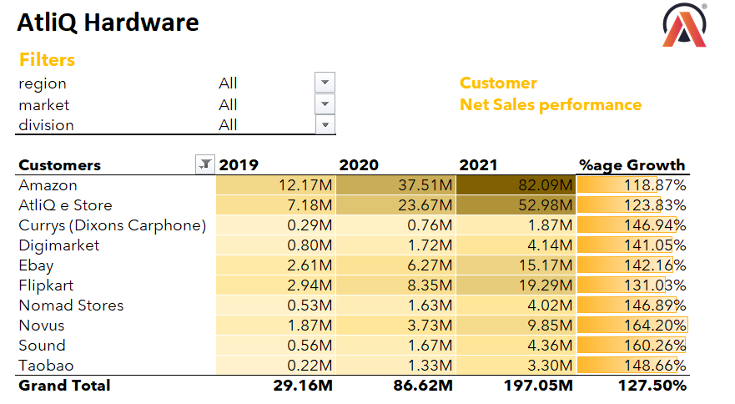

* 1. **Market Performance Report**

**Top 10 Market with lowest %age difference in the actual sales revenue and target sales revenue.** Japan showed the highest promise in achieving the 2021 Target

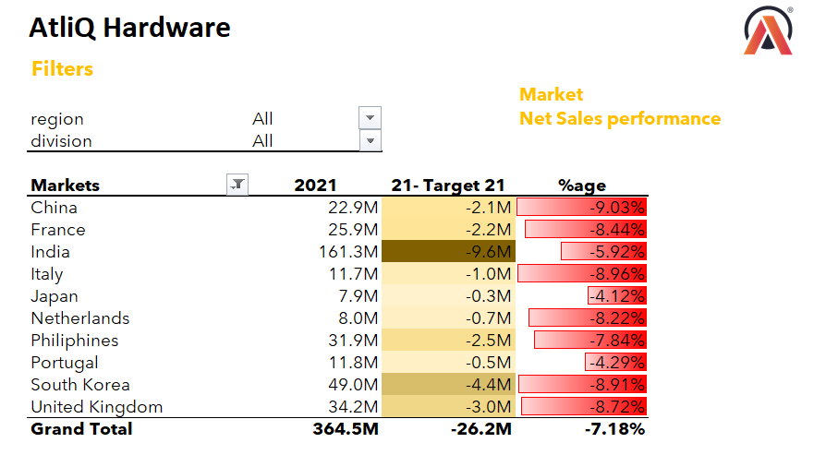

**Bottom 10 Market with highest %age difference in the actual sales revenue and target sales revenue**. Poland being the worst performers.

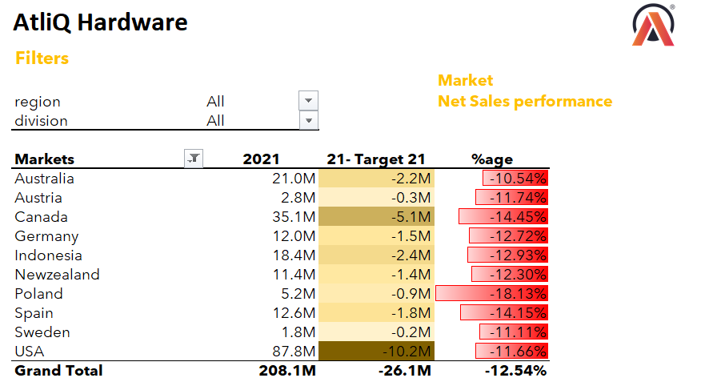

**Top 5 highest market performers in 2021**. India being at the top contributed 27 % of the total sales revenue.

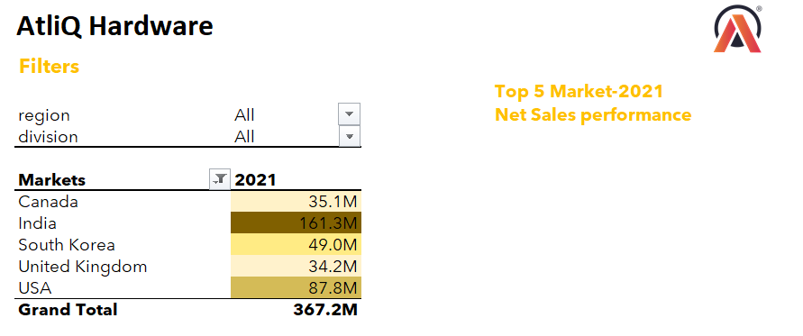

**4.3 Product Performance**

**Top 10 products with highest %age growth in 2021**. These 10-product contributed 8.5% in the total sales revenue.

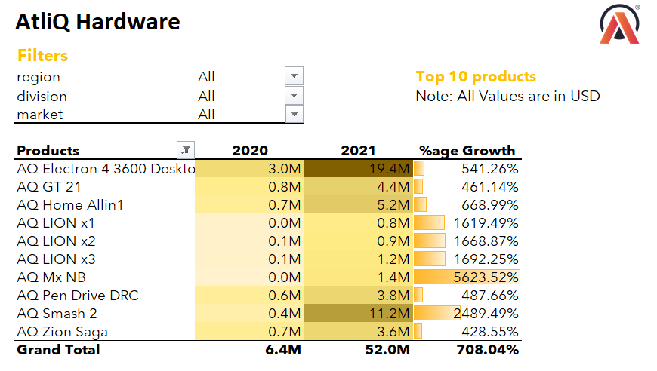

* 1. **New Products Launch**

**The company launched 16 products in FY 2021**. These products contributed 29 % in the total sales revenue

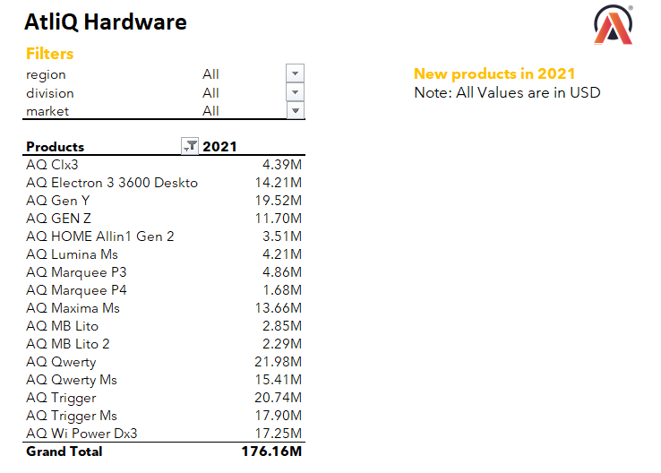

**4.4 Division-wise Report**

The PC division has seen the highest growth of 313 % but P&A division has contributed the highest (almost 55 %) in the net sales revenue in 2021 Division level report

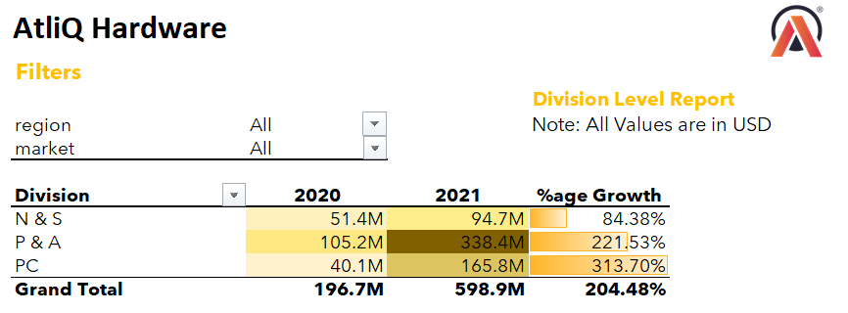

1. **Recommendations:**

The overall sales performance of AtliQ with 205 % growth in FY 2021 demonstrated steady growth, driven by top-selling products and contributions from all regions

During FY 2021, company launched 16 new products contributing 29 % in the total sales revenue, indicates successful marketing efforts. However, there is room to further improve customer retention and increase the repeat purchase rate.

Most markets in the European region have a high %age difference in actual sales in target sales in 2021, suggesting a need for targeted marketing campaigns or improved sales strategies in that region.

To optimize sales performance, AtliQ should consider enhancing customer loyalty programs, personalizing marketing initiatives, and expanding its market presence in underperforming regions.